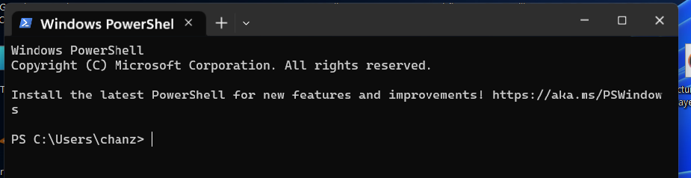

Open command line in windows



Choose Ubuntu

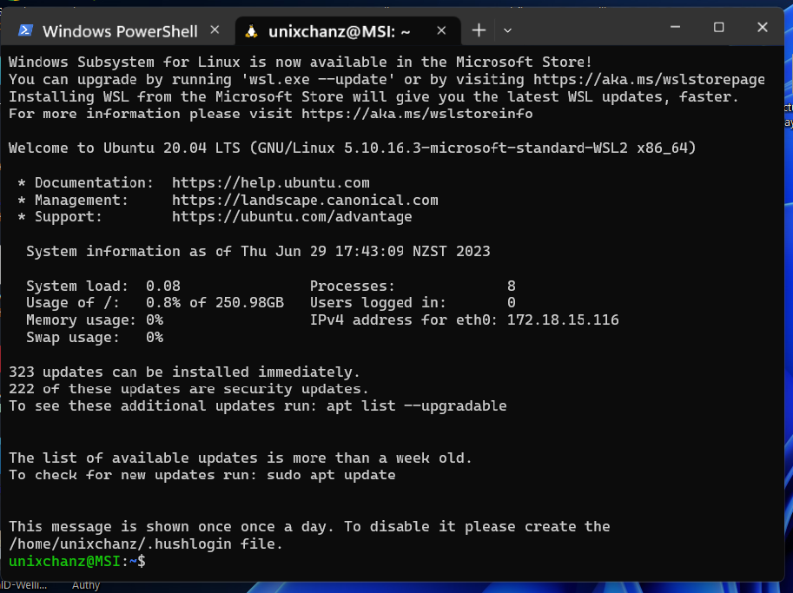

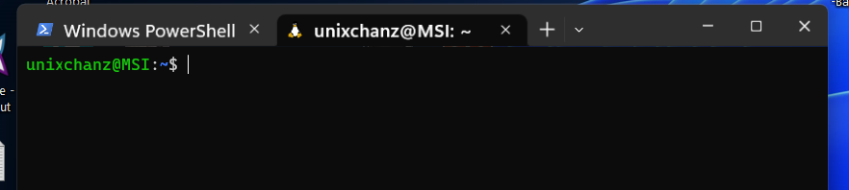

Shift to Windows disk

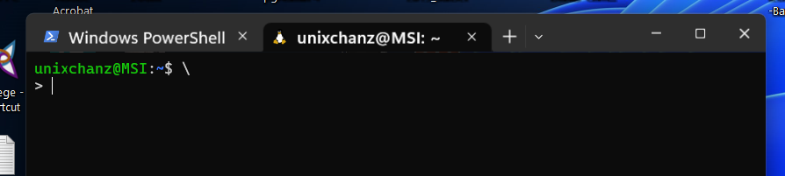

Cd / mnt

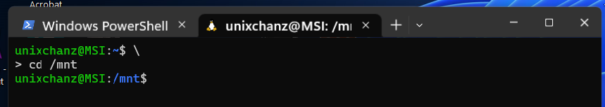

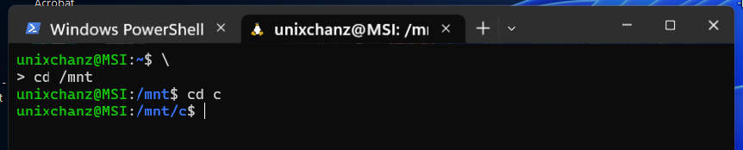

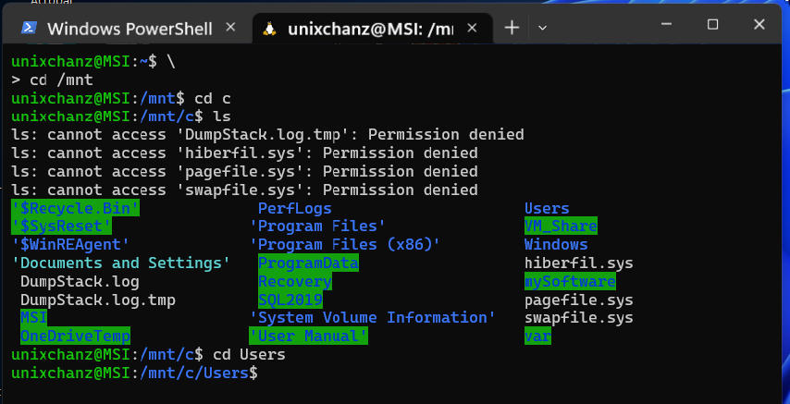

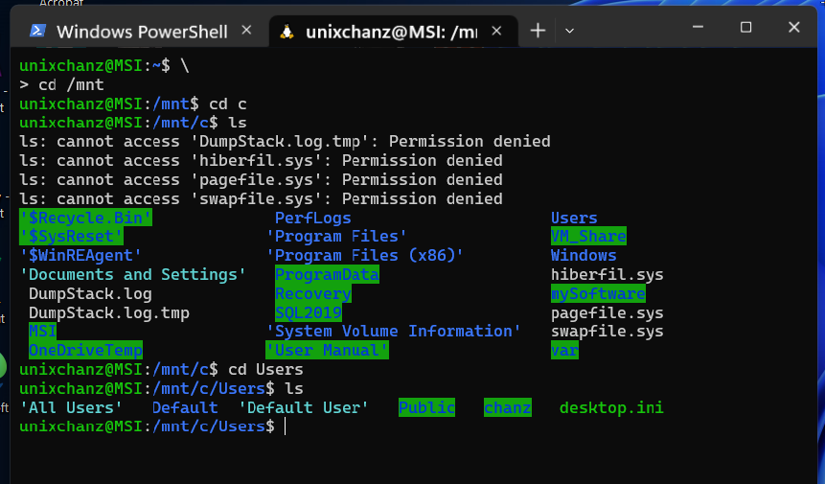

Mnt is a term in Linux, mnt is the mount point in which you mount your filesystem to your devices.

Mounting is the processing in which you make file system available to your devices.

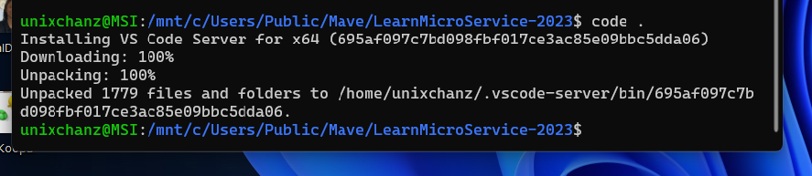

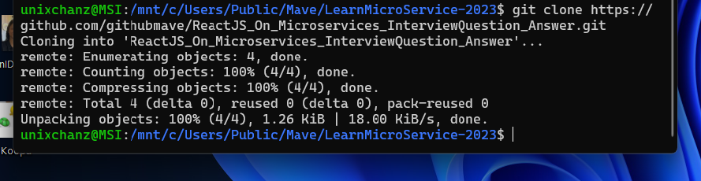

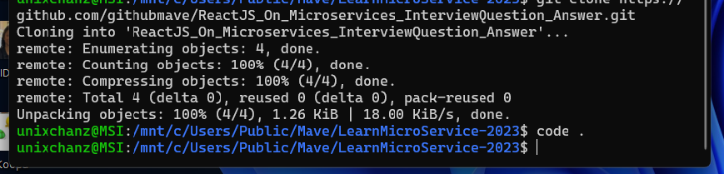

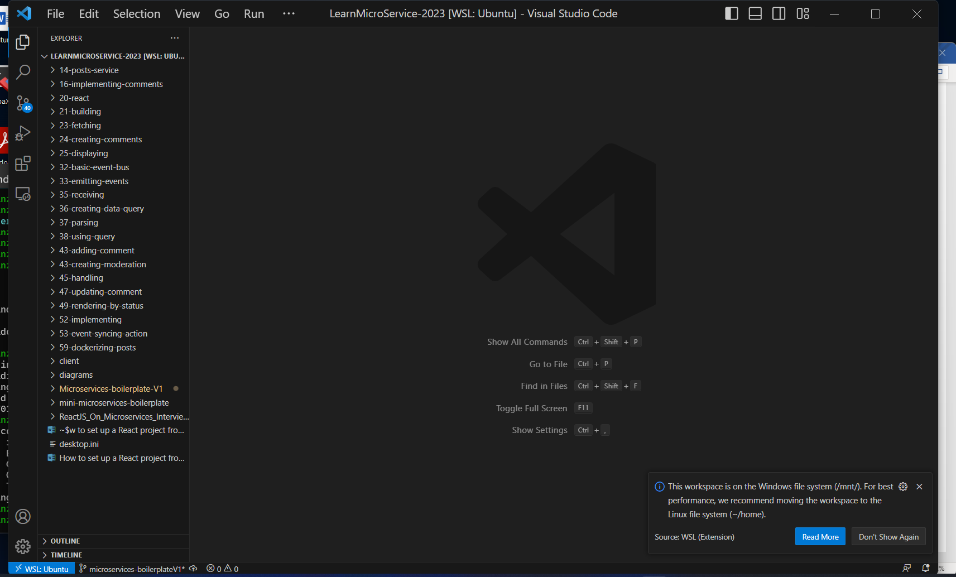

See if the npm version

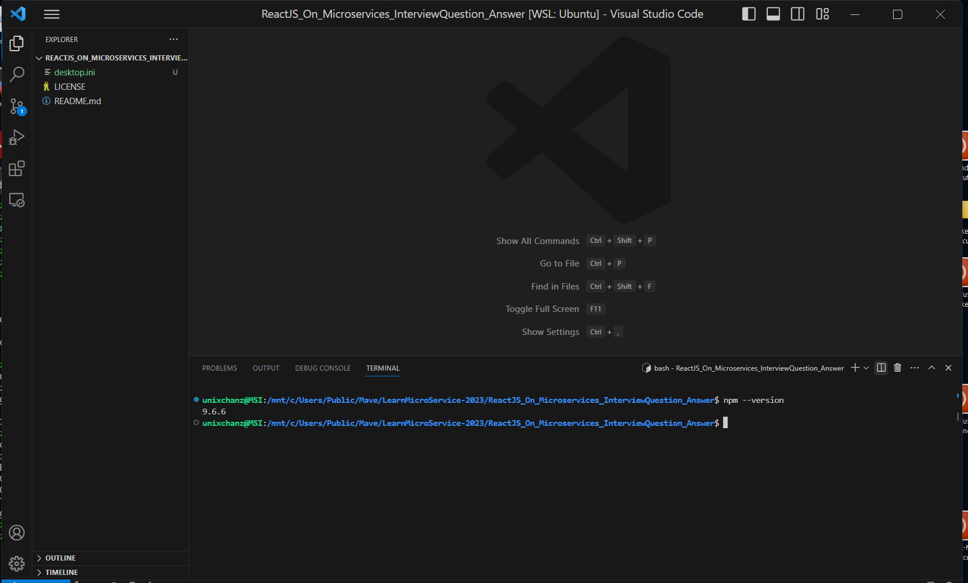

In version of npm on Ubuntu is: 9.6.6

See how to open VScode on Windows

Start a new project

. go to Ubuntu VSCode

Project tree

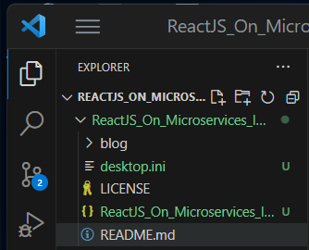

Git clone from github/ReactJS……

Make a new folder : blog

Go to blog, terminal: blog$nxp create-react-app client

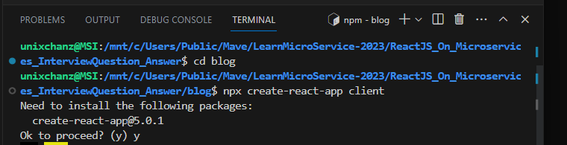

Press “y”

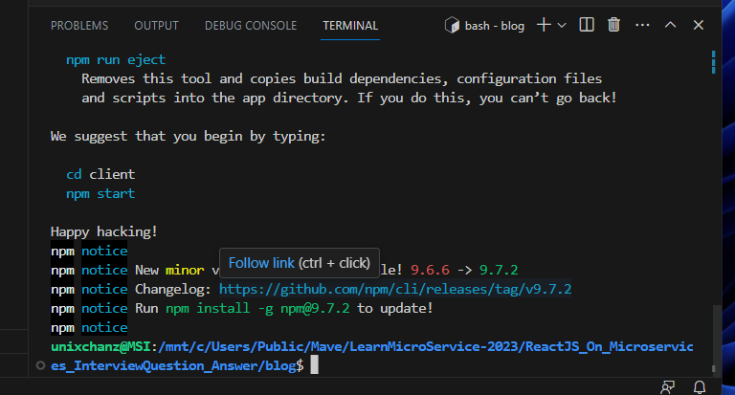

Make new folder: posts

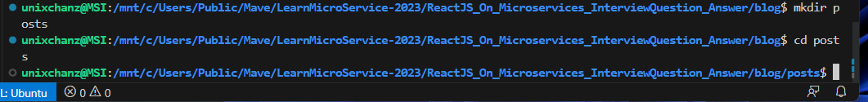

In the posts folder , **initialized package.json**

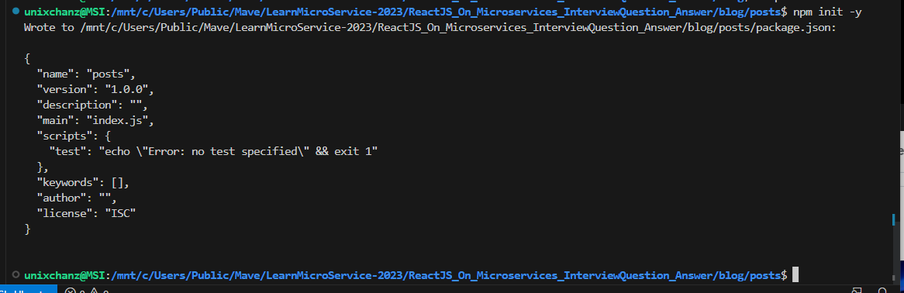

Within folder posts: Npm install express cors axios nodemon

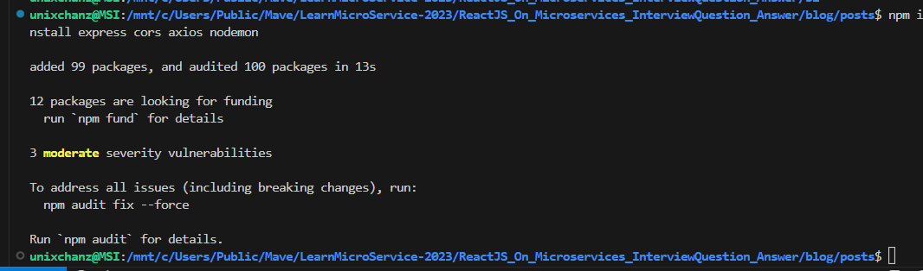

Go back to folder: blog

Ls: client posts

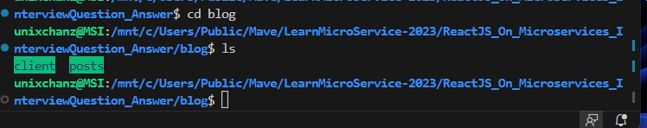

Make another folder: comments

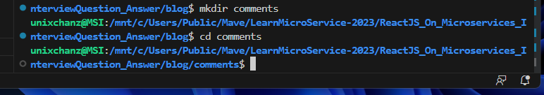

Make a server for comments: npm init -y

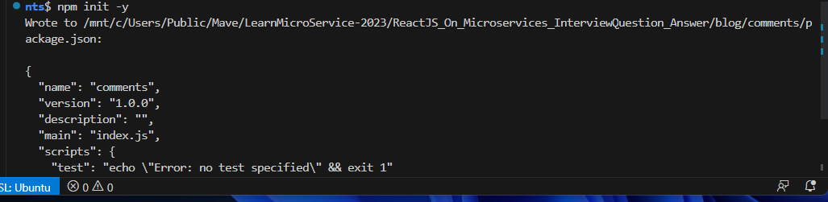

Within folder comments: npm install express cors axois nodemon



Go back to folder of blog



Create post services

Create Posts server

Go to folder posts, create index.js

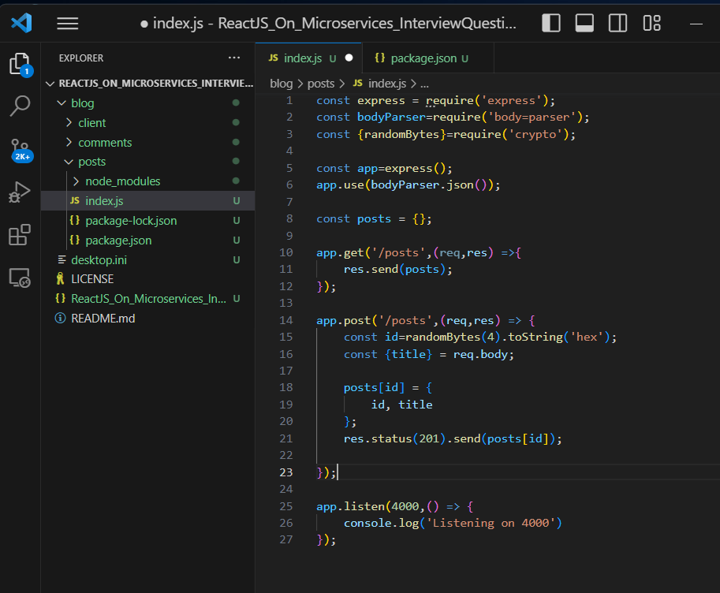

Alter posts/package.json

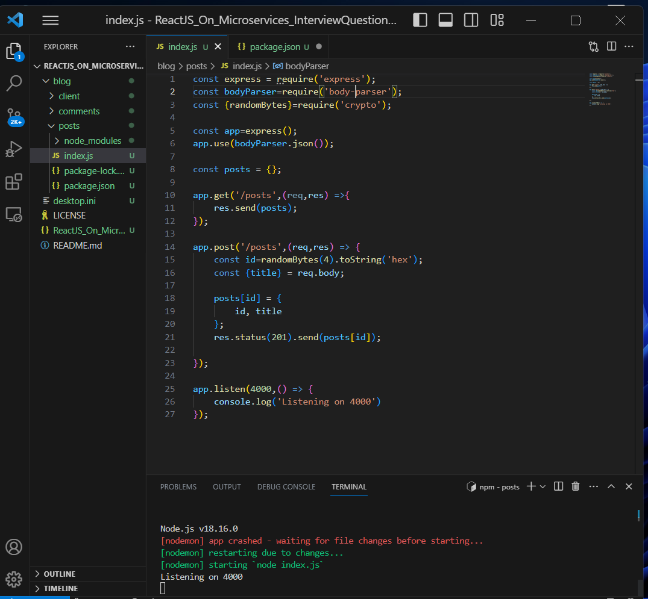

Go to posts folder

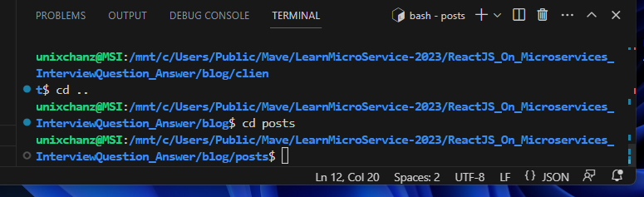

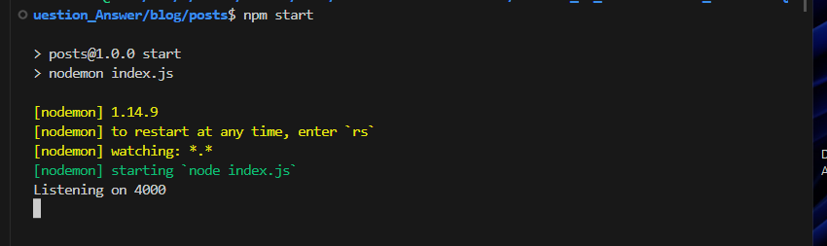

Go to POSTMAN, CLIKC to open

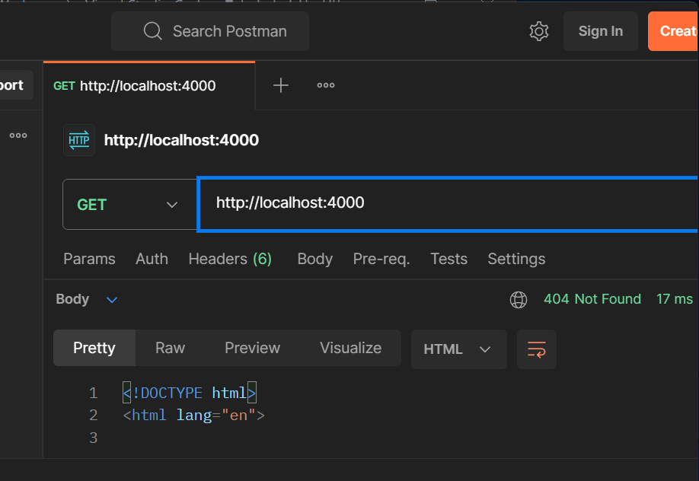

http: // localhost:4000/posts

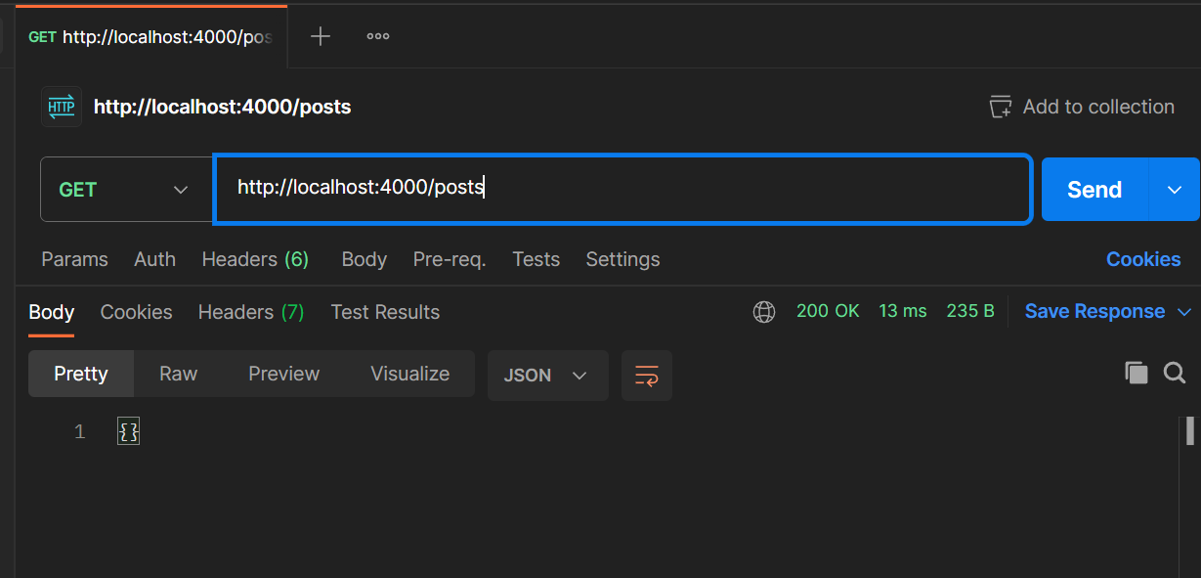

Header: Key: Content.Type, Value: application.json

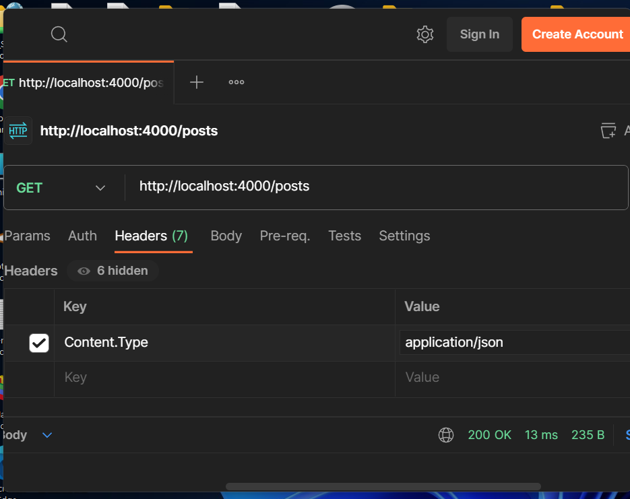

Body: choose RAW

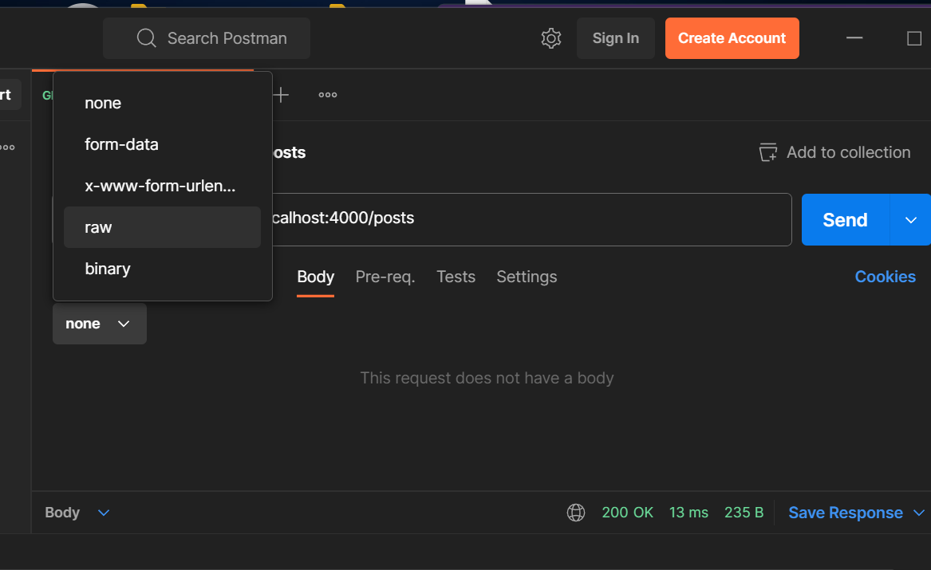

Choose to test POST method:

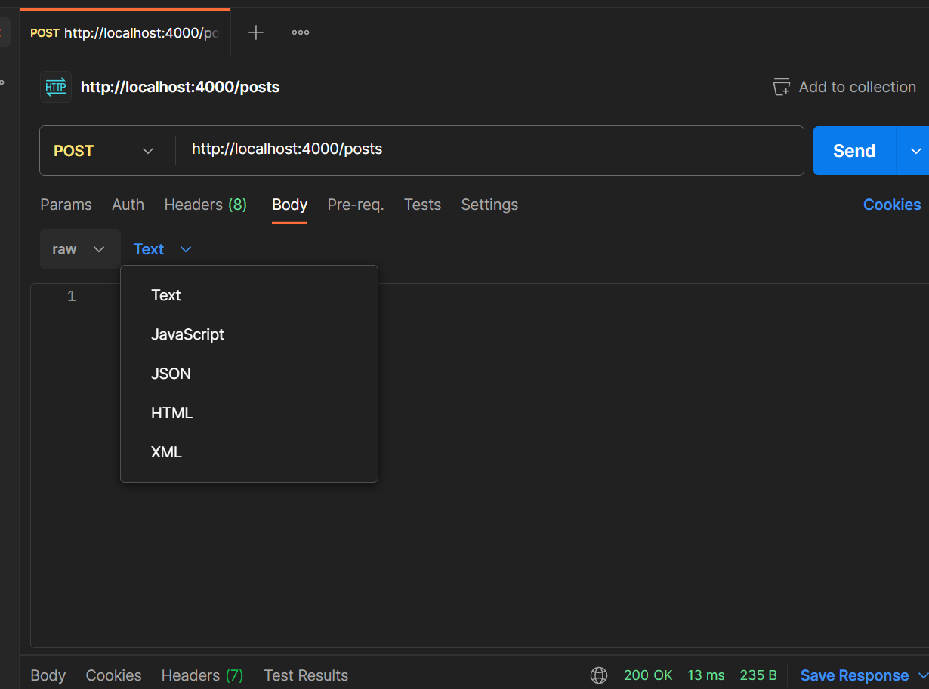

Type a post: title,

On postman/ body/ raw / Text/Json,

. type a post on the up

. press Send

. the posts[] pop up on the bottom

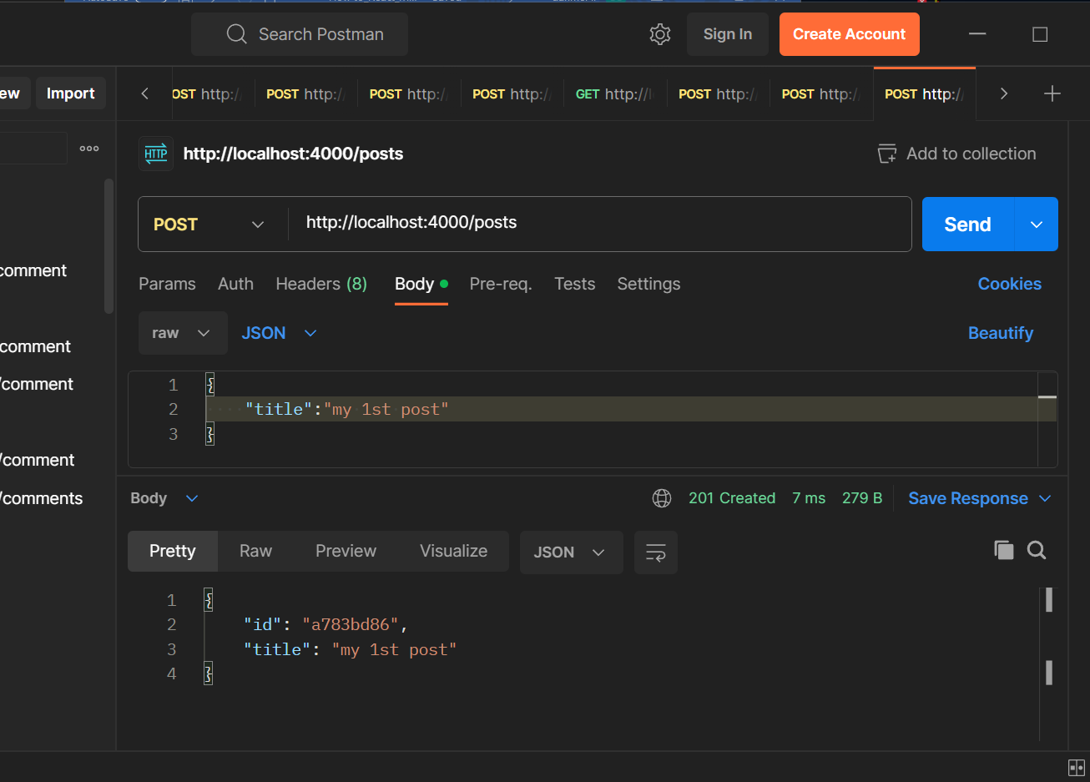

Create a comment service

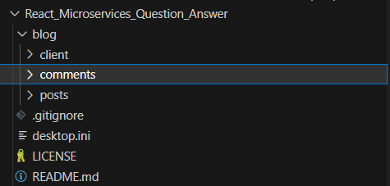

Create comments > index.js

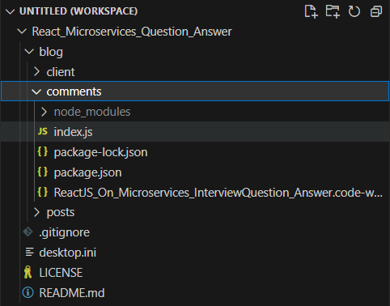

The comments > index.js

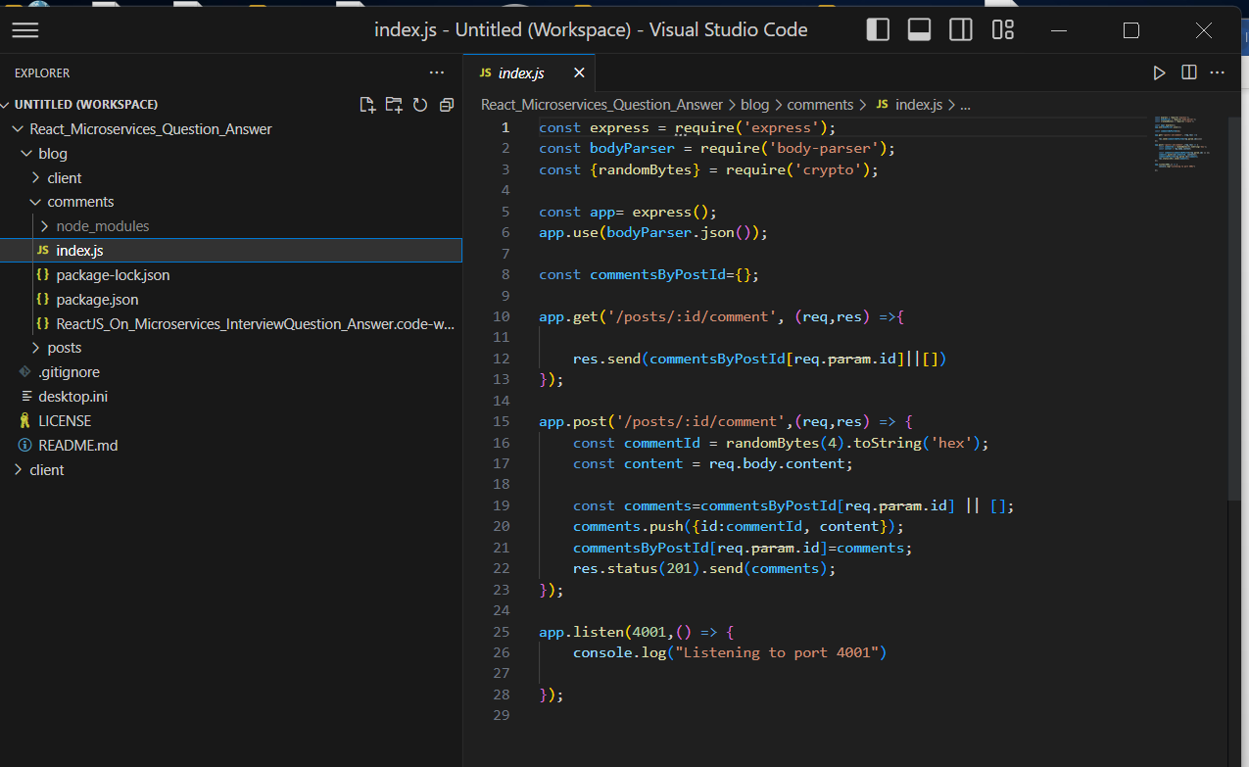

. in the terminal, go to blog/ comments > npm start

Pop up

Listen on 4001

……

Add React Client

Add client written in React

Client > src > : add PostCreate.js PostList.js , CommentCreate.js CommentList.js

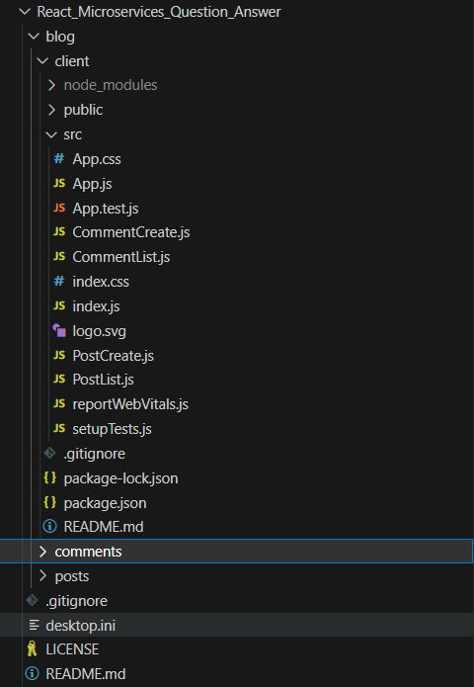

Add: PostCreate.js

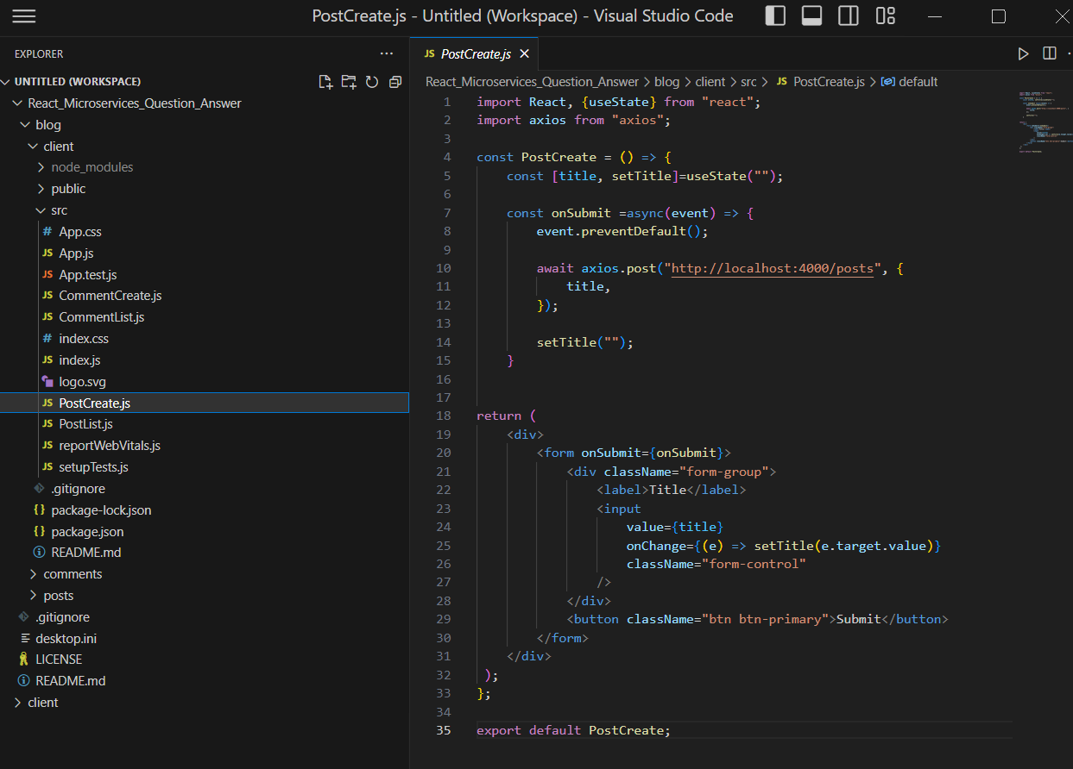

Add PostList.js

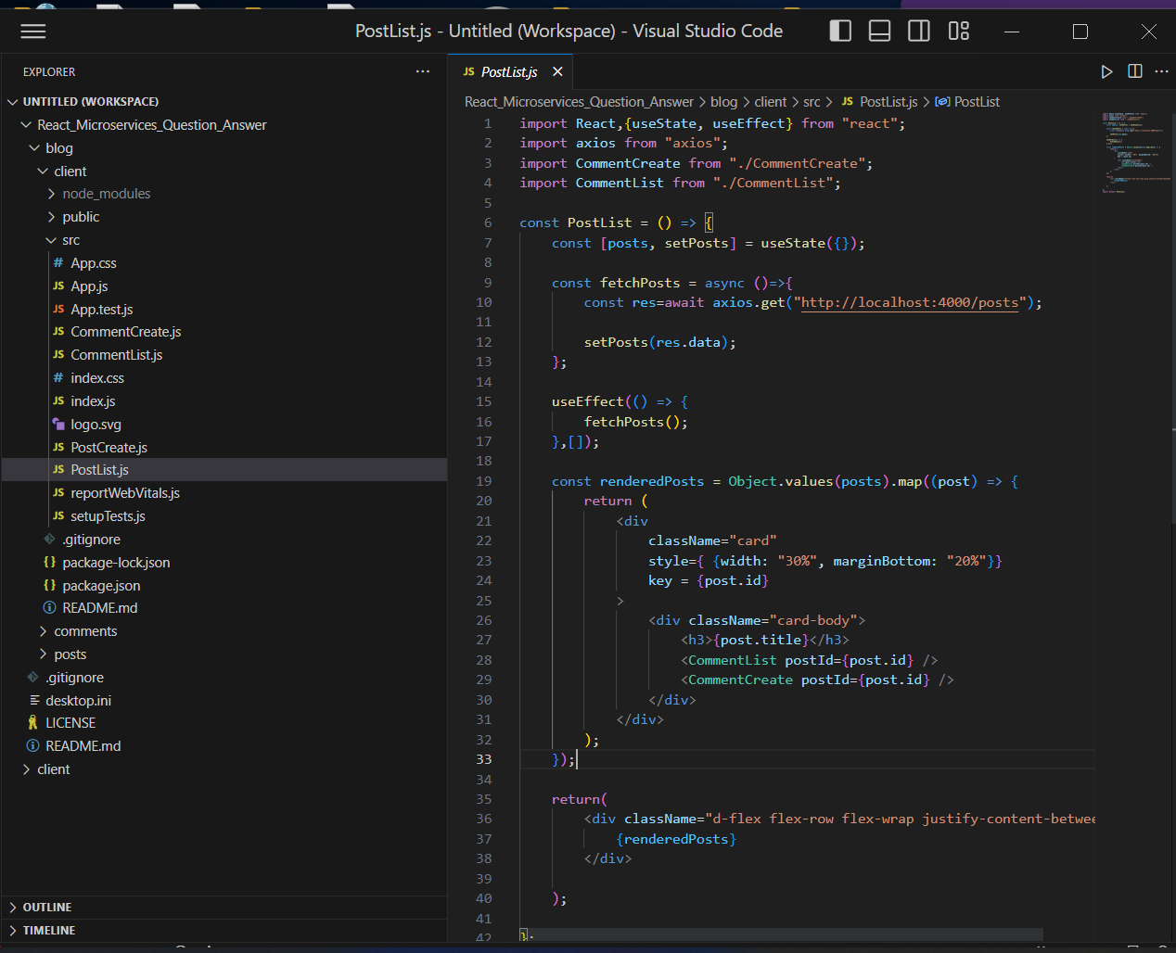

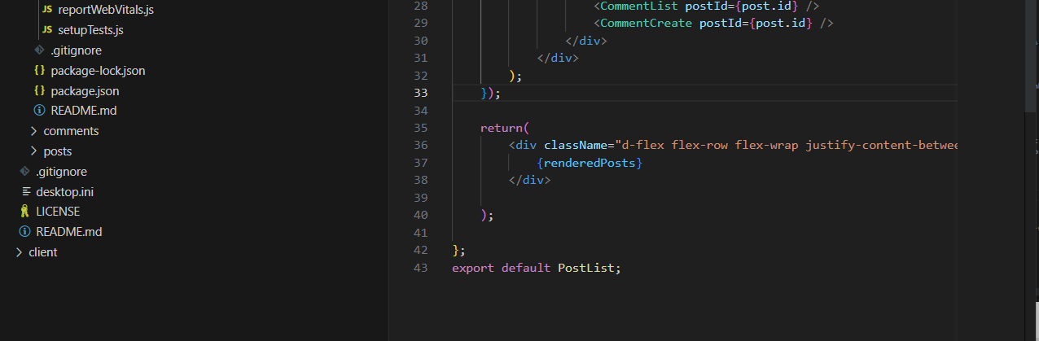

Add CommentCreate.js

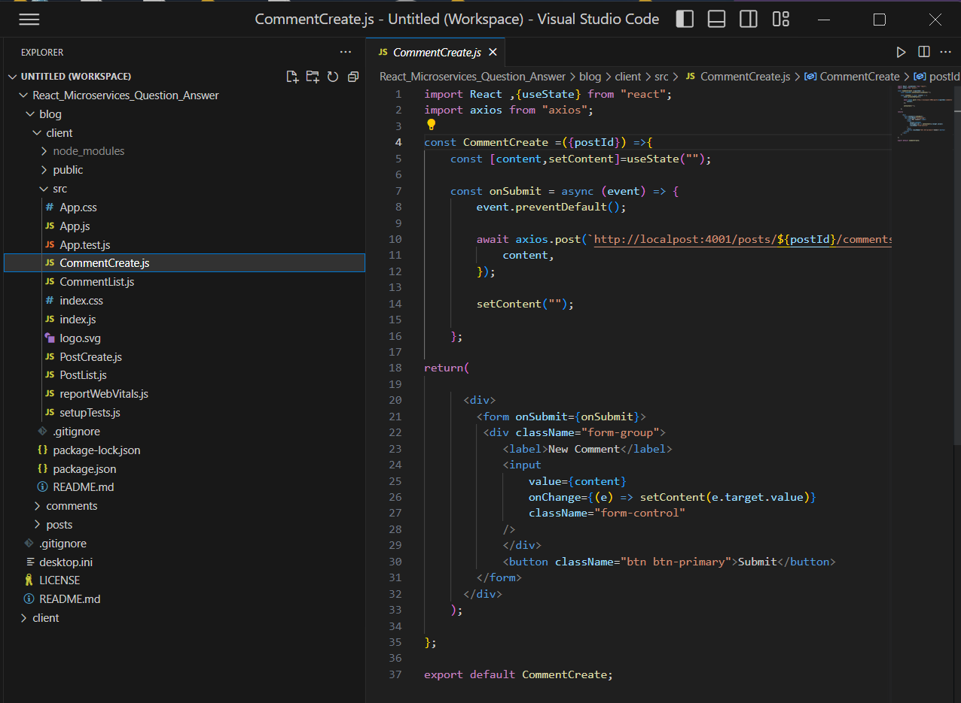

Add CommentList.js

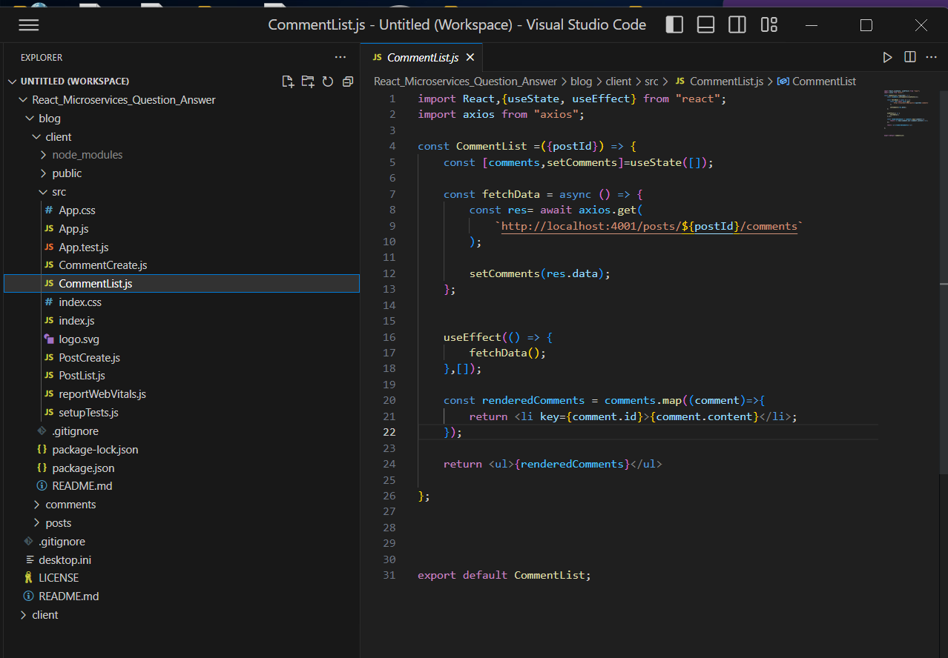

Npm install,

Then,

Npm Install axios

Go to blog > client:

Run : npm install axios

Return below package.json

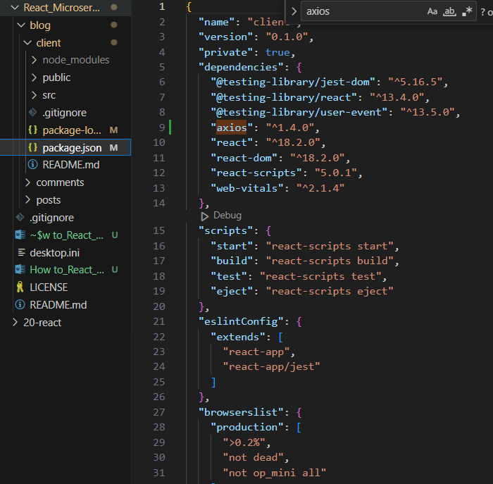

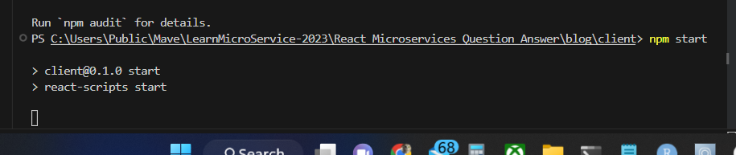

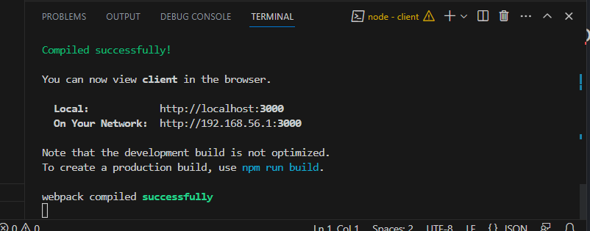

In the local machine

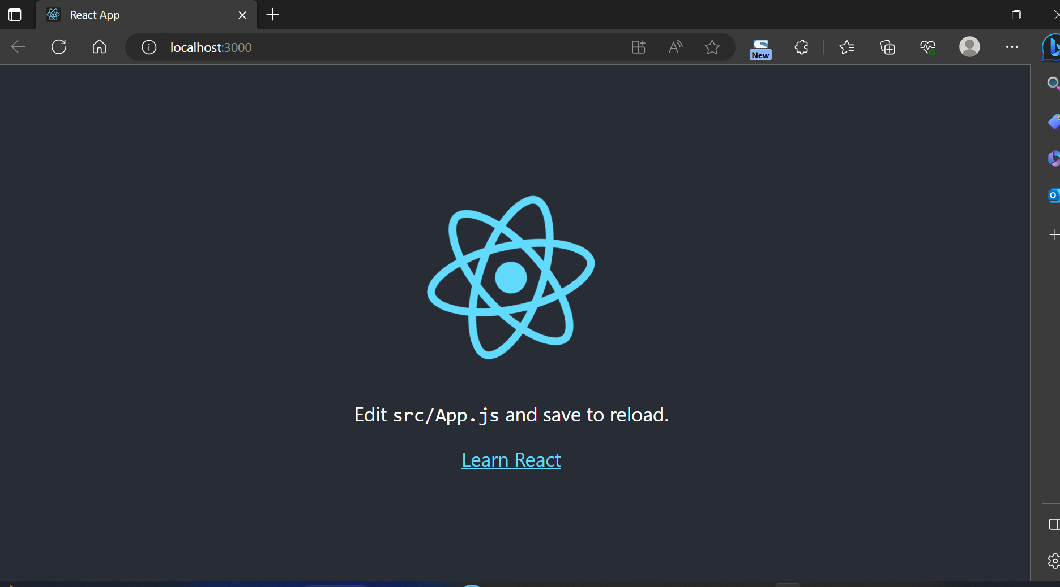

Since: <https://reactjs.org>



